Петрякова Елена Михайловна
учитель английского языка
МКОУ «Белозерская СОШ»

Дата проведения мероприятия: _________
1. Возраст учащихся: 11-12 лет
2. Организационная форма мероприятия: игра - соревнование.
3. Тема мероприятия: “Easter in Britain”.
4. Цель мероприятия: познакомить учащихся с культурой и традициями Великобритании.
5. Задачи мероприятия:
- Развивающая: развивать внимание, память, воображение; фантазию, устную речь, логическое мышление;
- Воспитательная: воспитывать уважение к культуре своей страны и стран изучаемого языка.
- Образовательная: формировать уважительное отношение к иностранному языку как средству межкультурного государственного общения.
6. Оснащение урока: наглядность (мультимедийный проектор), раздаточный материал, аудиокассета, ТСО (магнитофон).
7. Этапы урока:
I. Вступительная часть (речь учителя).
II. Основная часть (конкурсы).
III. Заключительная часть (выступление жюри и подведение итогов).

Ход мероприятия:
I. Вступительная часть.
Teacher: Hello, children. Today we will have a competition, you will take part in different contests, games, connected with the Easter British traditions, sing a song about Easter buns and as a result design Easter Bunny paper doll- the symbol of Easter. Let us divide into 2 teams. Our juries are Екатерина Викторовна and Татьяна Александровна.
II. Основнаячасть.
Teacher: Do you know the Holliday “Easter”? What do people do in Easter? (Learns share their ideas, teacher writes them on black board.) Good. Let’s look at the screen. (Слайд 1-4). Now let’s do some tasks.
1. “Read the letter and complete the spidergramme”. We’ve got the letter from our English friend, where he describes how he celebrates Easter. Read the letter and complete the spidergramme. Add more words from the letter to the spidergramme. Which team gives more words? Now we see which team remembers more words.
2. “Find the words to the pictures in the word-square pictures”. You should find the words to the pictures in the word-square pictures. Ok, good.
3.“Paint this picture according to the poem”. Now you can see all these words in this picture, but this picture is white-black and you should paint this picture according to the poem. The fastest team is the winner (children paint the pictures).
4.“Read the text Easter in Britain”.
5.“Answer the questions”. Now answer my questions. If you are right you take an envelope with the details you must put all pieces together. Open the envelopes after you answer all the questions.
1. What month is the Easter celebrated in Great Britain?
2. What two types of calendar do you know? If people celebrate Easter on the 1 April what calendar it is? And if on the 8 April what calendar it is?
3. What colours of Lilia do you know?
4. What Easter eggs do you know?
5. What is the symbol of new life?
6.“An envelope with the details of Bunny”. Teacher: Now open your envelopes and put all details together according to the instruction. (Teacher asks teams in turn. For each right answer Teacher gives an envelope to the pupils where there are the details of Bunny. Pupils should open the envelopes after they answered all the questions.) Instruction is in the backside of each detail.

III. Заключительная часть. Подведение итогов.
Jury: You have done a great job. You were bright, intelligent and resourceful. The winners are the pupils of 5A form.
Teacher: Now let’s watch the cartoon about Easter Bunny.
Teacher: You are brilliant! Thank you for a work, the lesson is over, you may be free.

Приложение (раздаточный материал)
1. “Read the letter and complete the spidergramme”.

2. “Find the words to the pictures in the word-square pictures”.
U | B | H | G | D | R | U | W | G | J | N | L
W | A | P | R | I | L | S | R | Y | H | O | E
A | S | Y | D | S | H | K | P | M | B | M | A
E | K | P | J | E | S | U | S | C | D | Z | S
W | E | G | G | S | I | T | S | H | X | H | T
A | T | H | I | E | K | Q | H | U | H | Y | E
E | C | A | L | E | N | D | A | R | O | G | R
T | U | F | D | L | J | N | F | C | S | C | L
U | C | A | N | D | L | E | T | H | Z | A | M
D | L | O | W | R | Y | U | F | F | U | R | O
E | Q | L | I | L | I | A | P | V | B | D | L

4.“Read the text Easter in Britain”.
Text
Easter Day is always on a Sunday, but the date varies from year to year unlike Christmas which is always on December 25.
In western churches such as in the United Kingdom, Easter was celebrated on April 16, 2006 whereas in Eastern Orthodox churches the date was April 23. The reason for this is that in the west the date is calculated using the Gregorian calendar which is different to the Julian calendar which is used in the east.
Easter Sunday is a happy day for Christians. They believe that Jesus' resurrection or coming alive shows that death is not the end of everything. Church bells are rung and churches are decorated with flowers such as white or gold lilies which are associated with Easter.
In Europe and America parents hide chocolate eggs in the garden for children to find. In many countries children are given hard boiled eggs.
Eggs are associated with new life when the chick breaks from the egg. The egg is a symbol of a new life. So eggs have always been part of celebrations at Easter.
(The text is from ‘Trend UK’)

6.“An envelope with the details of Bunny”.
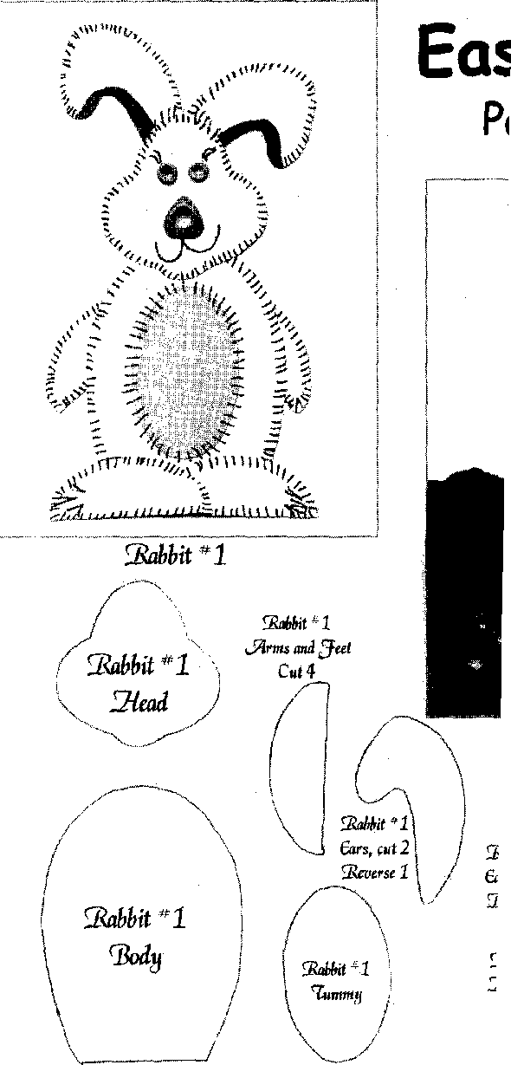

3.“Paint this picture according to the poem”.

Colour the picture
Two eggs are red.
Three eggs are blue.
One egg is green.
The chickens are yellow.
One lamb is white.
One lamb is black.
Two bowl is orange.
The bunny is brown.

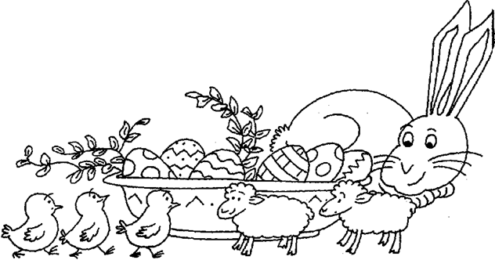

Информационный источник:
- http://tea-english.ru/?page_id=1726
- http://prezentacii.com/angliiskii_yazik/7538-easter.html
- http://www.youtube.com/watch?v=PYwHUbD422A
- http://www.lingvaflavor.com/pasxa-v-anglii
- http://enjoyeng.ru/interesnye-novosti/prazdniki-v-anglii/kak-prazdnuyut-pasxu-v-anglii
- http://www.alleng.ru/engl-top/594.htm

