Приложение 1

Прочитайте текст о Роберте Бернсе и кратко расскажите о нем одноклассникам на английском языке.

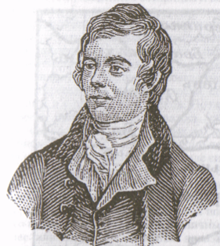

Robert Burns is a Scotland’s national poet. He was born in 1759 in Scotland. His father was a poor farmer. But he gave his two sons education.
Robert Burns wrote many poems. His poems are known not only in Scotland but also in many other countries.
On the 25th of January people in Scotland celebrate “Burn’s Night”– the birthday of their national poet.

Words:

poet – поэт
give education – дать образование
are known – известны
celebrate – праздновать
“Burn’s night – ночь Бернса

Прочитайте текст о хаггисе и расскажите о нем кратко своим одноклассникам на английском языке.

Haggis is a national food in Scotland made of a sheep. It is like a sausage. People can eat this food with vegetables.
People make haggis when they have Robert Burns birthday. Robert Burn’s is a national Scottish poet.
People in Scotland celebrate his birthday on the 25th of January.

Words:

like a sausage – похож на колбасу
vegetables – овощи
scottish poet – шотландский поэт
celebrate - праздновать

Прочитайте текст о традиционном костюме шотландцев и о национальном инструменте и расскажите о них кратко своим одноклассникам на английском языке.

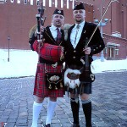
Kilt is a traditional Scottish costume. It is made of the woolen cloth – tartan. Kilt is a skirt for men.
Men began to wear a kilt in the 17th century. But it is popular now.

Bagpipers are people who play the bagpipes, the traditional Scottish instruments.

Words:

traditional – традиционный
costume – костюм
woolen cloth – шерстяная ткань
tartan – тартан
to wear – носить
century – век
bagpiper – волынщик
bagpipe – волынка

