|  |  |  |
| --- | --- | --- |
| http://www.wiza.md/i/main_page/kitchen_paint_1.jpg  **_ itchen** | http://st.houzz.com/simgs/e271204a0f74a7bc_4-8966/eclectic-living-room.jpg  **Living r_ _ m** | |
| http://www.inred55.ru/data/images/150big.jpg  **B _ d roo _** | http://www.tissu-nn.ru/_ph/2/2/26651313.jpg  **Hal _** | |
| http://www.wiza.md/i/main_page/kitchen_paint_1.jpg  **_ itchen** | | http://st.houzz.com/simgs/e271204a0f74a7bc_4-8966/eclectic-living-room.jpg  **Living r_ _ m** | |
| http://www.inred55.ru/data/images/150big.jpg  **B _ d roo _** | | http://www.tissu-nn.ru/_ph/2/2/26651313.jpg  **Hol _** | |

Приложение №3

Приложение №1

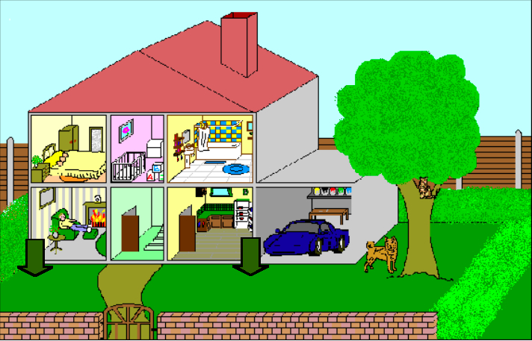

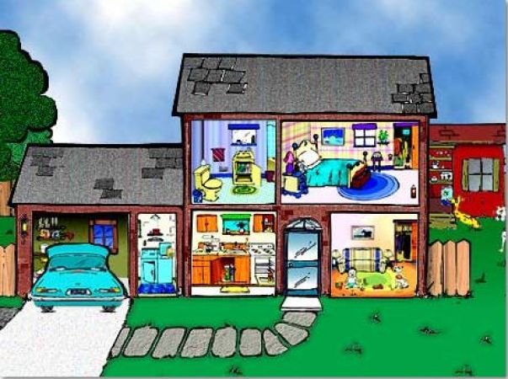

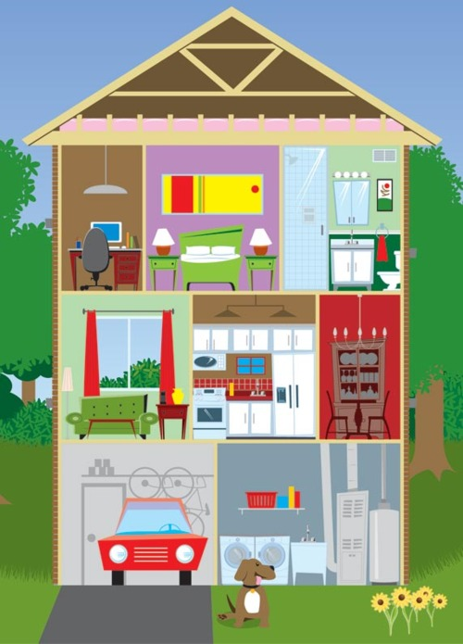

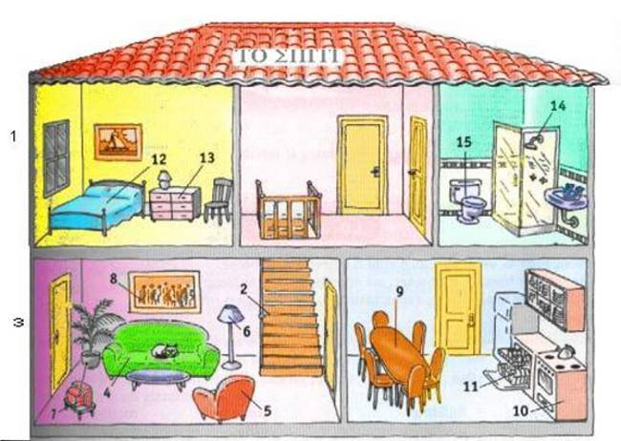

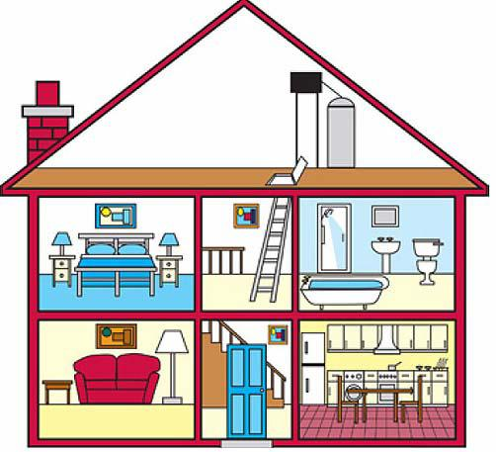

Приложение №2

|  |
| --- |
| **a bed room** |
| **a living room** |
| **a kitchen** |
| **an armchair** |
| **a table** |
| **a mirror** |
| **a TVset** |
| **a wardrobe** |
| **a carpet** |
| **a chair** |
| **a fridge** |
| **a cupboard** |

Приложение №4



